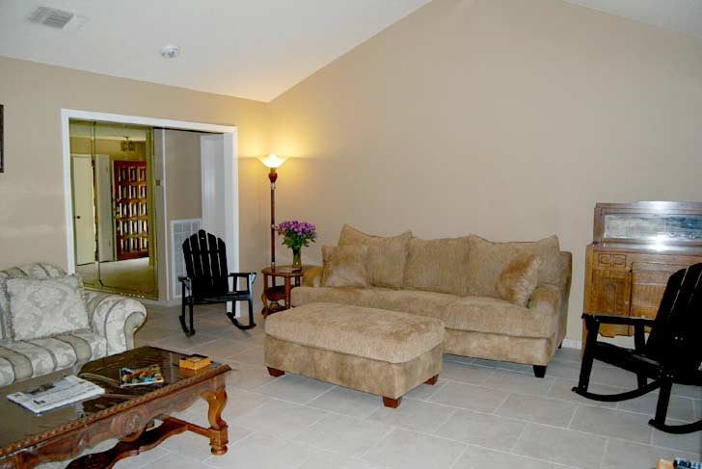**Resident Room Cleaning**

**Cleaning Procedures**

**Resident Room Cleaning**

**Routine Cleaning Tasks**

1. Empty trash containers / spray interior / spot clean exterior / reline
2. Dust using dusting cloth or extension duster
3. Disinfect sink (10 min. dwell time) and mirror
4. Disinfect toilet (10 min. dwell time)
5. Disinfect tub and shower (10 min. dwell time)
6. Check and refill dispensers / disinfect dispensers
7. Spot clean glass
8. Make bed
9. Clean dresser and night stand
10. Spot clean chairs / tables / vertical and horizontal surfaces
11. Spot clean and vacuum carpet
12. Dust mop and damp mop floor

*Work in circuits not circles; beginning at your cart, working through the area (combining tasks so you’re doing more than one thing at a time / having everything you need when and where you need it), and finishing at your cart. The direction of the circuit, i.e. right to left, or left to right, isn’t important, the objective is to establish a routine so nothing is missed. In the long run, it can be effective to reverse directions occasionally to obtain a different perspective.*

**Routine Cleaning Procedures**

1. First Circuit
   * 1. **Empty trash containers.** If there is only paper in the trash can it may be emptied. If there are liquids, food or other items that have soiled the liner, change it. If the liner leaked, rinse the inside of the trash can and allow it to air-dry before relining. Wipe down the exterior of the trash can with disinfectant cleaner to remove spots and stray marks.
     2. 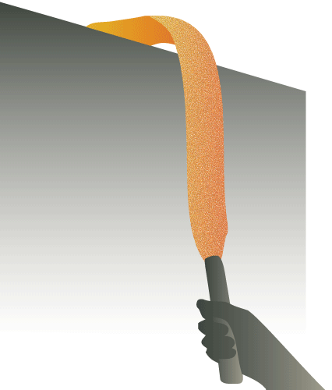**Dust:** Always work from the top of the room downward to prevent re-soiling of previously cleaned surfaces.

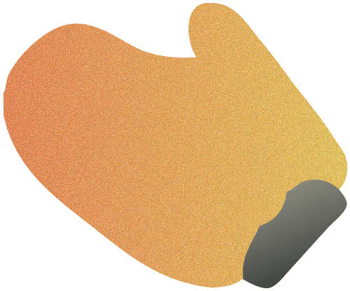Use an extension duster to reach high and low surfaces. Use a dusting cloth or mitt on mid-level surfaces. This will save strain on your body from bending low or stretching high.

**Resident Room Cleaning**

**Cleaning Procedures**

**Resident Room Cleaning**

**Routine Cleaning Procedures**

1. Second Circuit
2. **Disinfect Sink:** Apply disinfectant cleaner to all surfaces of the sinks (inside, outside, top, bottom, handles, spout, and any exposed plumbing underneath. Apply to the walls immediately surrounding the sink and to all dispensers. Allow to stand wet on the surface for ten minutes. Respray surfaces as necessary to have enough liquid to clean. Wipe surfaces with a clean soft cloth to remove soils, and leave surfaces streak-free.

Clean mirror (including frame) with paper towels or a squeegee.

Optionally, spray all surfaces with disinfectant cleaner and immediately wipe to clean, removing all streaks. After cleaning, re-spray the surfaces with disinfectant cleaner and allow to air dry to provide the required ten minute dwell time.

Another option is to wring a cloth in a utility pail filled with disinfectant cleaner and fold it to make an 8-sided cleaning cloth. Wipe the surfaces to clean, turn the cloth to a clean side and wipe again. Allow surfaces to air dry.

1. **Disinfect Toilet:** Option 1: Apply disinfectant cleaner to the toilet(s) using a trigger sprayer to spray the inside surfaces and to spray a bowl brush or bowl swab sufficiently to apply the disinfectant cleaner up under the flush ring.

Spray all outside surfaces of the toilet, including undersides and other hidden areas.

Allow disinfectant to stand wet on the surfaces for 10 minutes to achieve 100% germ kill. After ten minutes have passed, reapply disinfectant cleaner as necessary to have enough liquid to clean, and scrub the interior with a bowl brush or swab. Flush several times to rinse.

Re-spray the outside surfaces as necessary and wipe to clean. If necessary, wipe the outside surfaces a second time with a clean, dry, soft cloth to remove streaks and to shine chrome.

 Option 2: Apply disinfectant cleaner to interior surfaces using a bowl brush or bowl swab and a container dedicated to cleaning the inside of toilets and urinals only.

Wring a cloth in a utility pail of disinfectant cleaner, fold it to make an 8-sided cleaning cloth, and wipe the outside surfaces to clean. Turn the cloth to a clean side frequently and wipe the surfaces a second time. Allow surfaces to air dry. Do not use this utility pail and cloth on sinks after using to clean toilets.

**Resident Room Cleaning**

**Cleaning Procedures**

**Resident Room Cleaning**

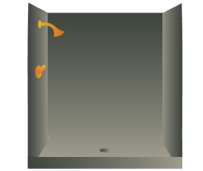**Routine Cleaning Procedures**

1. Second Circuit (continued)
2. **Disinfect Tub and Shower:** Spray disinfectant cleaner on all surfaces of the tub and shower. Allow to stand wet for 10 minutes. Wipe all surfaces until clean and streak free. Re-spray surfaces as necessary to have enough liquid to clean.

Optionally, spray the surfaces of the tub and shower and immediately wipe until clean and streak free. Once all surfaces have been cleaned, re-spray with disinfectant cleaner and allow to air dry.

Another option is to wring a cleaning cloth in a utility pail filled with disinfectant cleaner. Fold it into an 8-sided cloth and begin wiping all surfaces of the tub and shower.

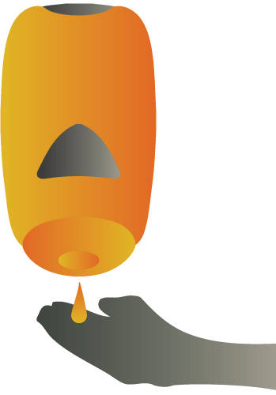After wiping a surface clean, turn the cloth over to a clean side and wipe it again to apply enough disinfectant cleaner to stand wet on the surfaces as they air-dry.

1. **Dispensers:** Check and refill dispensers as necessary. Spray and wipe the outside of dispensers with disinfectant cleaner.
2. Third Circuit
3. 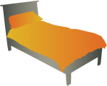**Spot clean glass,** including entry windows, door glass, display case glass, glass tabletops and any other glass in the room. Lightly spray glass cleaner on fingerprints and smudges. Wipe to remove the spot and to dry the surface streak-free.
4. **Make the bed** using existing linen unless soiled or otherwise directed.
5. **AST-CanTrashSm.gif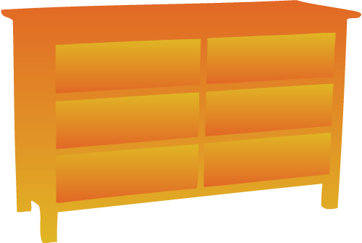Clean Dresser and Night Stand:** Wring a cleaning cloth in a utility pail of disinfectant cleaner. Fold to make an 8-sided cloth and wipe the top, sides, front and any open shelves of the dresser(s) and night stand(s) turning the cloth as necessary. Apply surface treatments if applicable.
6. **Spot clean chairs, tables, and vertical and horizontal surfaces.** Spray visible soils on non-upholstered chairs, on tables, and on all vertical and horizontal surfaces. Wipe to clean leaving no streaks or residue.

Optionally, use a utility pail and cloth. Wring the cloth and wipe surfaces as needed to remove visible soils.

1. Fourth Circuit
2. 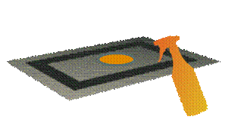**Spot Clean Carpet.** Use a freezing aerosol gum remover to remove fresh gum. Use a liquid gum dissolver to remove older gum.

On smaller spots (3” across or less) apply carpet spot remover to spills and other carpet spots until the surface is damp, not wet. Fold a clean, dry cloth into an 8-sided cloth, place over the spot, place a heavy weight on the cloth and go do something else for 20 to 30 minutes.

**Resident Room Cleaning**

**Cleaning Procedures**

**Resident Room Cleaning**

**Routine Cleaning Procedures**

1. ****Fourth Circuit (continued)
2. **Spot Clean Carpet** (continued)

****When you return, remove the weight, turn the cloth over to a dry side, and step on the pad with your toe once or twice. This will remove 95% of all fresh spills and spots.

Use machine-spotting techniques to remove larger spots.

Vacuum carpeting, avoiding any previously spotted areas that remain damp.

1. 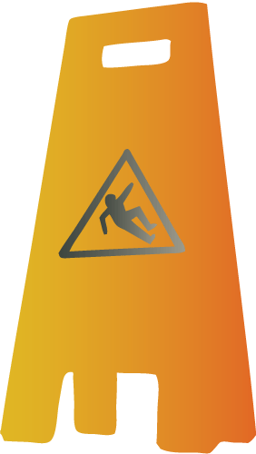**Dust mop floor.** Use a previously treated or microfiber dust mop to remove dust and debris from the area. Dust mop under furniture and along the edges of the room, paying particular attention to the corners, working from the inside of the corner outward to move soil away from, not into the corner. Dust mopping into the corner can pack the soil into the corner and create a “rounded” corner. Use a putty knife if necessary to remove soil and move it out where the dust mop can pick it up.

**Damp mop floor.** Place “Wet Floor” signs appropriately. Using a standard damp mop and mop bucket, or microfiber damp mopping pads, begin mopping at the far corner finishing at the door. Rinse mop or change pads as needed. Leave signs in place until floor has dried.